# CS 255 System Design Document

## UML Diagrams

### UML Use Case Diagram

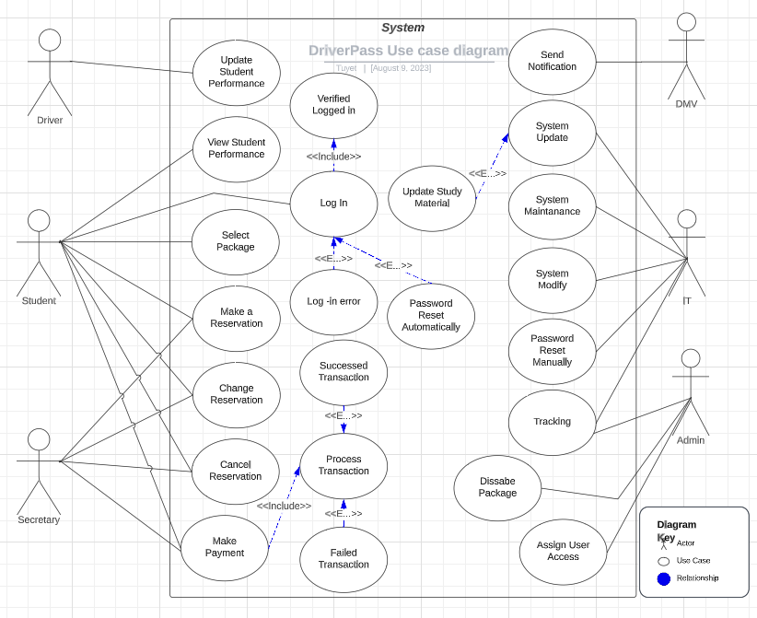

### UML Activity Diagrams

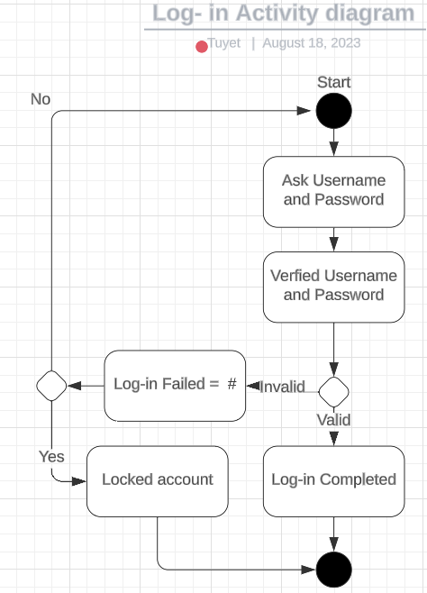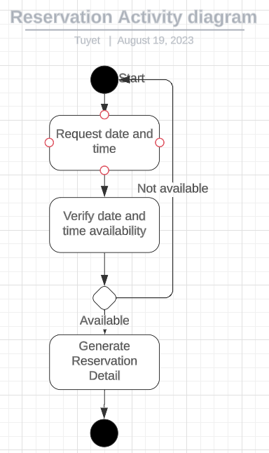

### UML Sequence Diagram

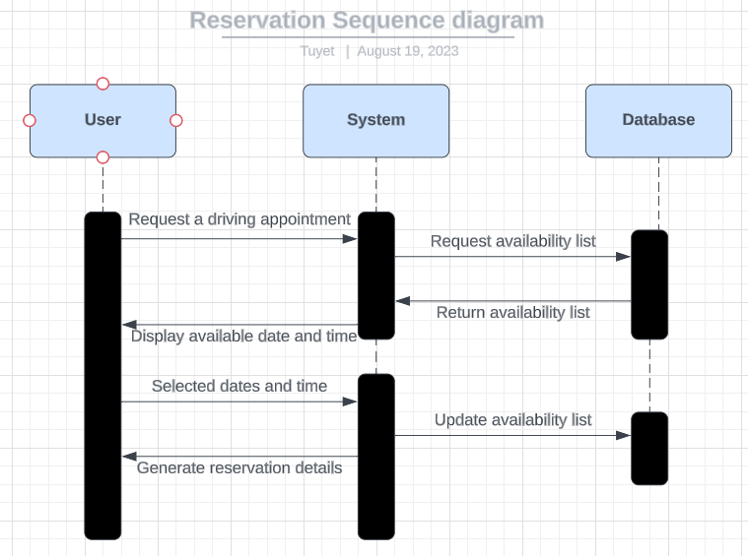

### UML Class Diagram

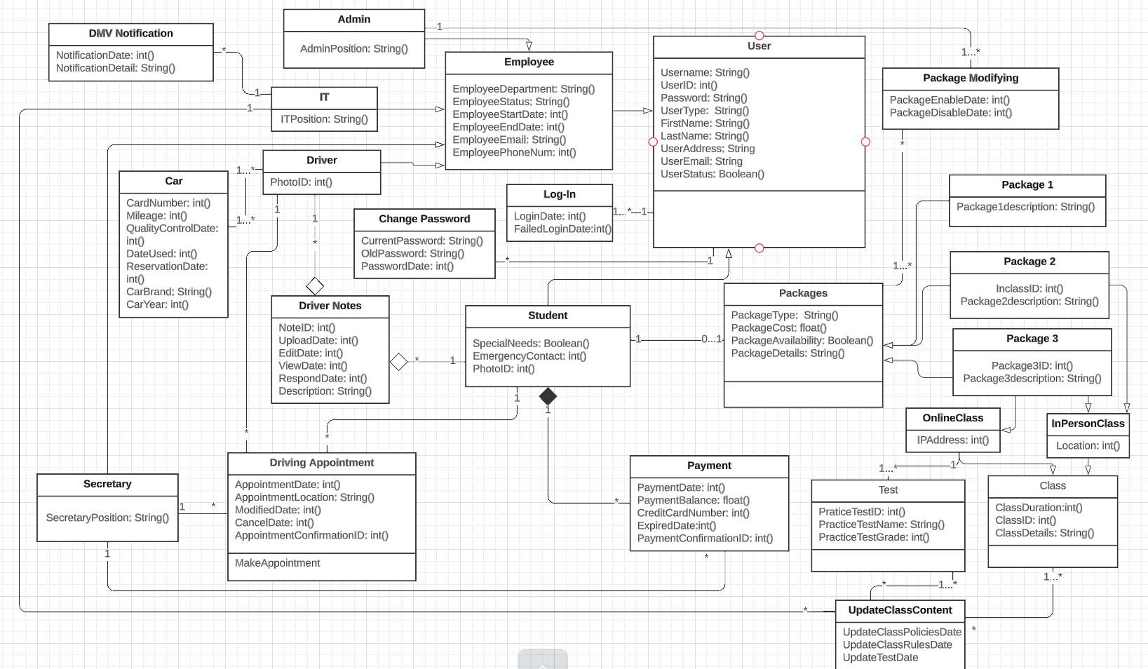

## Technical Requirements

The hardware requirements DriverPass should include but not be limited to computer networks that support the website, they included monitors, mouses, keyboards, monitors, smart phones, laptops, tablets, etc… Different types of devices that run different operations and browsers for testing purposes, devices with various sizes, a secured phones system where the secretary could assist the students, databases to store business information which could be cloud or physical or both and backup database, a network provider and a printer when the Admin wants to print the tracking reports.

The software requirements for the project are different types of operating systems, an integrated development environment for the website, a cloud database or physical storage system, possibly a third-party business communication software for example Microsoft Team or Google Workspace, a platform for developers to build, test, deploy, modify, maintenance, and manage the system required a docker, security software to protect the data and various type of web browsers

The tools requirements should be the coding languages that are compatible with the purpose of the website, for example, HTML, CSS, JavaScript, or PHP for front-end development, and they all can display pictures as the client wishes to implement the feature, as for back-end the language could be Java, Python, or Ruby, the programming environment could be Visual Studio, Eclipse, AWS, etc. The internet connects to the server and system monitor tools.

The infrastructure necessary for the website is server location or cloud provider, internet service, system power, insurance, backup and recovery plans, system blueprints, different manuals, and documentation, security and system policies.